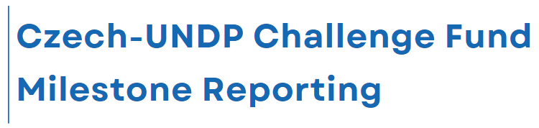

Project Title:

Milestone number
Innovator
Local Partner
Project Locations
Start date – End Date
Funding (total USD) | UNDP Award | Co-Funding

SUMMARY
The executive summary is a concise brief on the progress towards the expected results during the reporting period. The section should include context and key developments of the project; progress against expected results; key challenges and risks faced in the implementation (and what has been done to mitigate them); lessons learned as appropriate; utilization update - mention the total project budget (as proposed in the application); report on cumulative utilization (indicating the % utilization in brackets) on utilization during the reporting period; key recommendations. Suggested length – 1 page maximum

BACKGROUND
This section should provide a short introductory of the project, including an overview of the situation analysis, objectives and changes in the context/situation. It should be kept brief, expand only on key changes that might affect implementation. This part should include brief background of project and its rationale; context including linkage to other ongoing projects/programs; Project Approach, including Project Set up and management and coordination arrangements; listing of the main responsible parties. Suggested length - half a page maximum

MAIN ACTIVITIES and KEy RESULTS
This section should focus on results backed by evidence of achievements. Give an overall and clear sense of the ‘before-and-after’ of the project intervention. Describe and analyse activities but emphasis on linking them more solidly to expected results by also including references and evidencing how the total number of activities helped to reach the results within reporting period. Suggested length – 1-3 pages.

PARTNERSHIP AND SUSTAINABILITY
Briefly describe all partnerships, including new ones built in the course of the reporting period. Report on the major impact that these partnerships have on results. How stakeholders, counterparts and/or local communities are/were engaged in implementation of the project to ensure sustainability of the project. Suggested length – half a page

KEY CHALLENGES LESSONS LEARNED AND RECOMENDATIONS
Mention key challenges encountered during implementation period and lessons learned as well as the way forward. For each of them, describe successful approaches taken to address challenges and highlight recommendations for future consideration in implementing the Project. This should include any modifications that needed or need to be made to proposed targets as well data collection and monitoring to track progress. Suggested length –1 page

MEDIA COVERAGE AND PUBLIC OUTREACH
(Please summarize the media coverage and public outreach; include links to relevant articles and media)

PROJECT’S FINANCIAL PERFORMANCe
Please attach original budget sheet and add report current utilization of budget to the email.

Deliverables and ANNEXES
Please include (attach to the email or share via online storage) deliverables listed in the Contract.
Please include any additional information such as articles, leaflets, publications, reports and drafts of studies developed during the project implementation.
Please include up to 3 photos relevant to the project implementation relevant for the current milestone.

Checklist
☐ Deliverables described in the Contract included/attached
☐ Photos attached
☐ Budget sheet attached
☐ Invoice attached

Prepared by:

Date:

Name of the responsible person:

Signature:

